Ideation Phase
Define the Problem Statements
Date | 24 June 2026
Team ID | SWTID-2026-5360
Project Name | Heart Disease Analysis
Maximum Marks | 2 Marks
Customer Problem Statement Template:
Create a problem statement to understand your customer's point of view. The Customer Problem Statement template helps you focus on what matters to create experiences people will love.

A well-articulated customer problem statement allows you and your team to find the ideal solution for the challenges your customers face. Throughout the process, you’ll also be able to empathize with your customers, which helps you better understand how they perceive your product or service.

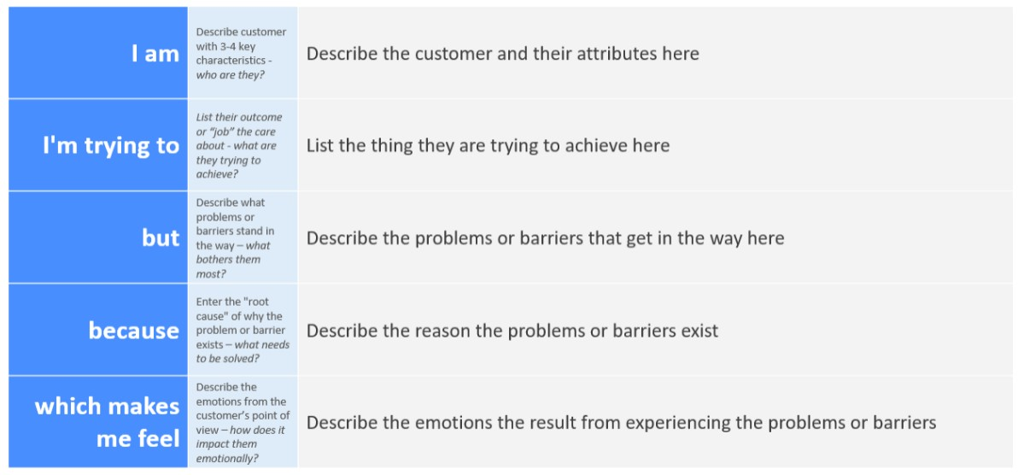

Reference: https://miro.com/templates/customer-problem-statement/
Example:


Problem Statement (PS) | I am (Customer) | I'm trying to | But | Because | Which makes me feel
PS-1 | A Healthcare Professional | Analyse patient health records to identify heart disease risk factors. | The available data is scattered across multiple records and difficult to interpret. | There is no centralized interactive dashboard for comprehensive analysis. | Inefficient in making timely and informed clinical decisions.
PS-2 | A Hospital Administrator | Monitor heart disease trends and patient outcomes for better healthcare planning. | Existing reports are static and do not provide real-time insights. | Traditional reporting tools lack interactive visualization and dynamic filtering capabilities. | Challenged in making data-driven strategic decisions.

